INTRODUCTION

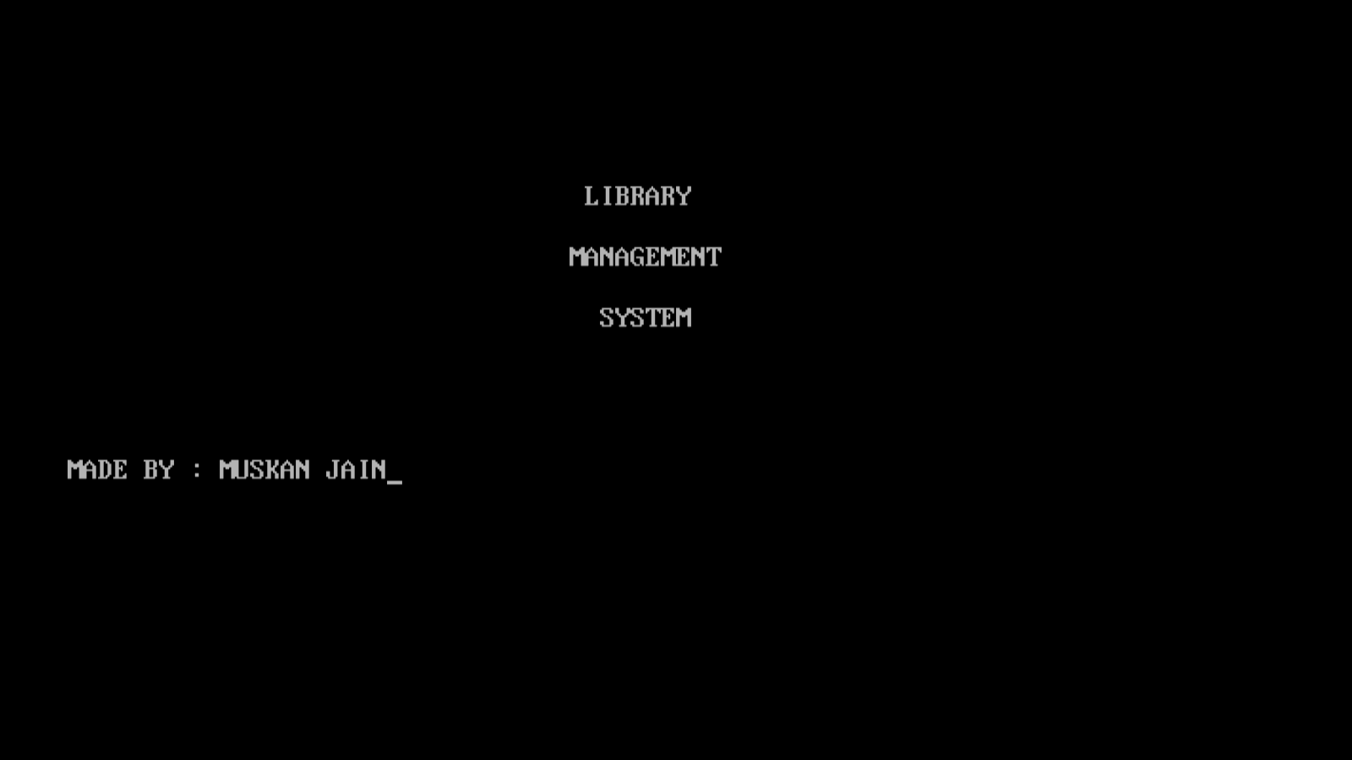

MAIN MENU

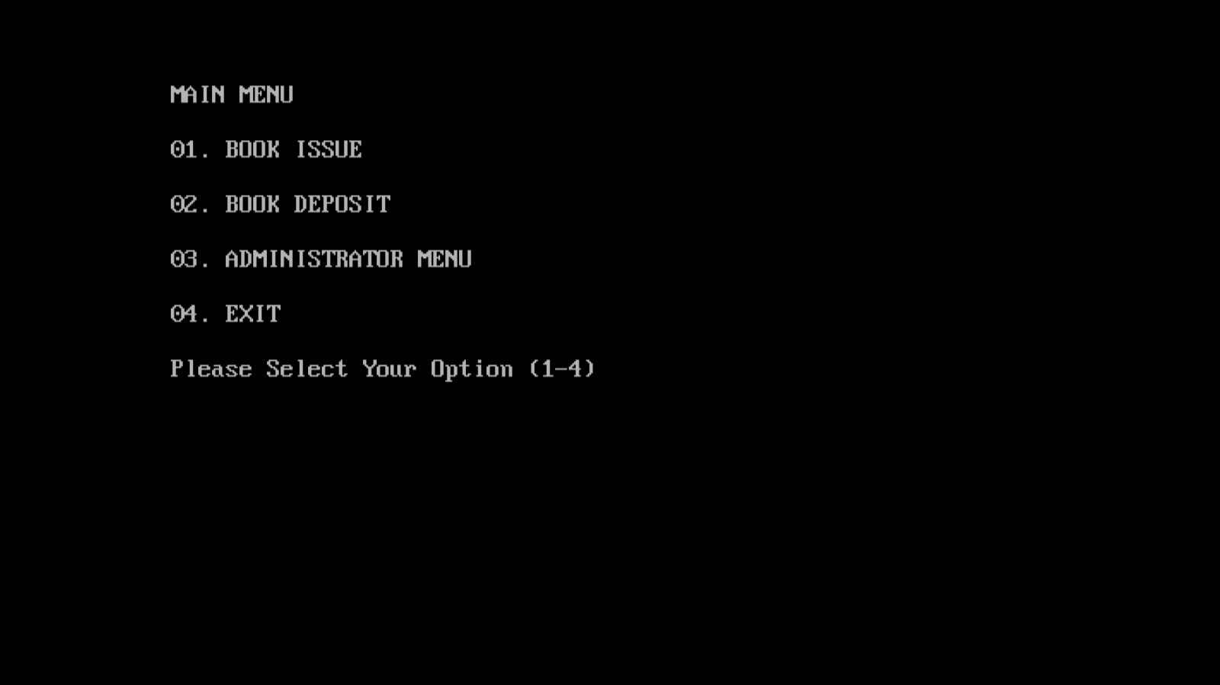

ADMINISTRATOR MENU

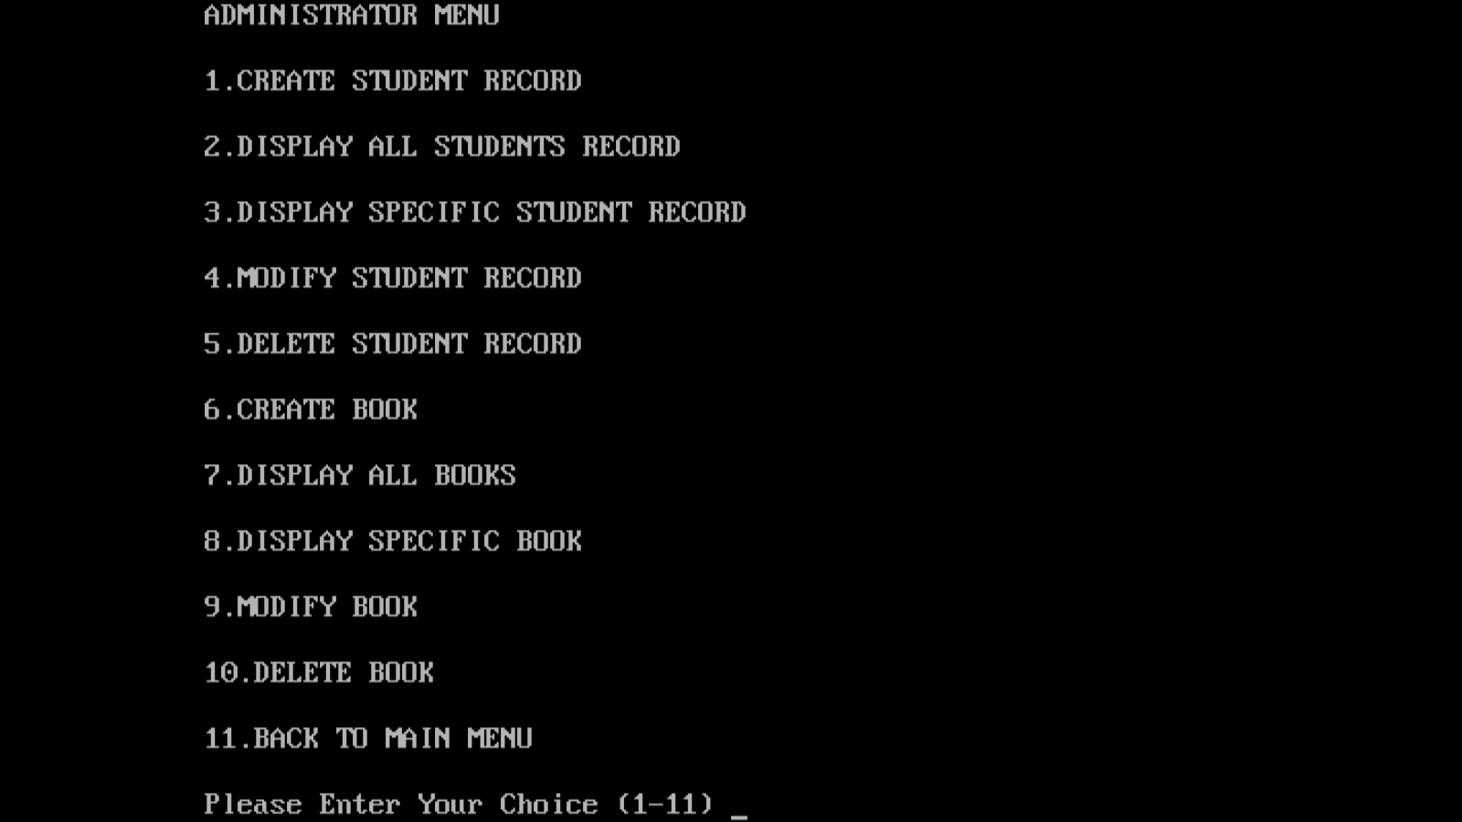

ADDING BOOK TO COLLECTION

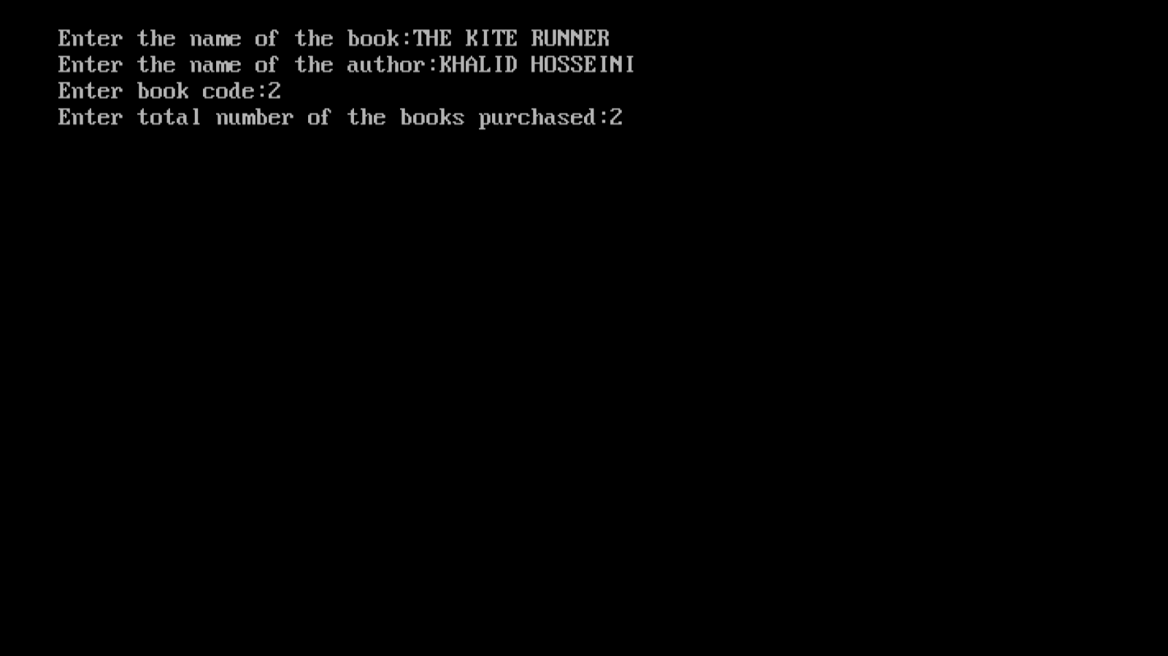

ADDING A NEW MEMBER

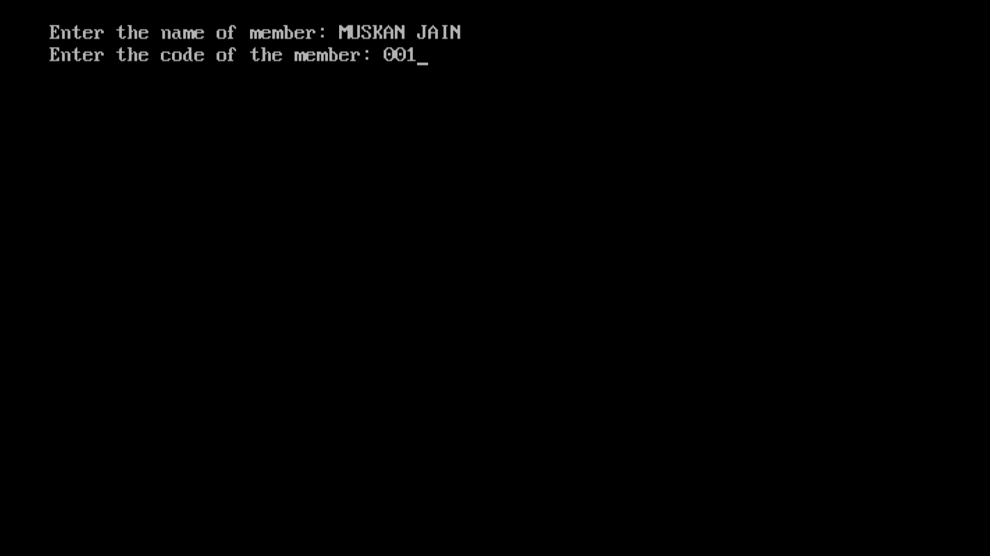

ISSUING BOOK

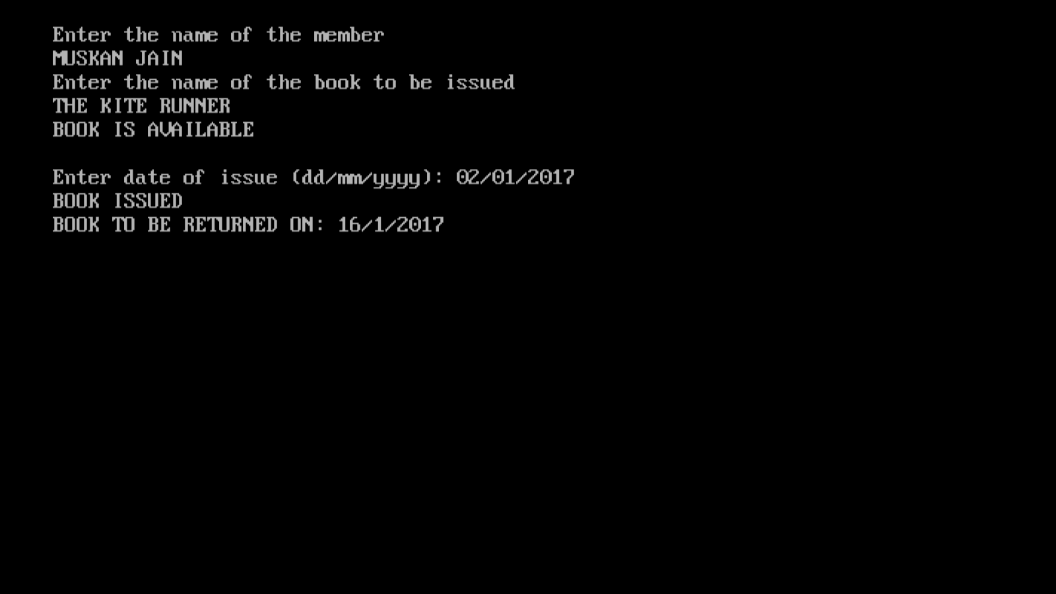

DISPLAYING ALL BOOKS IN THE COLLECTION

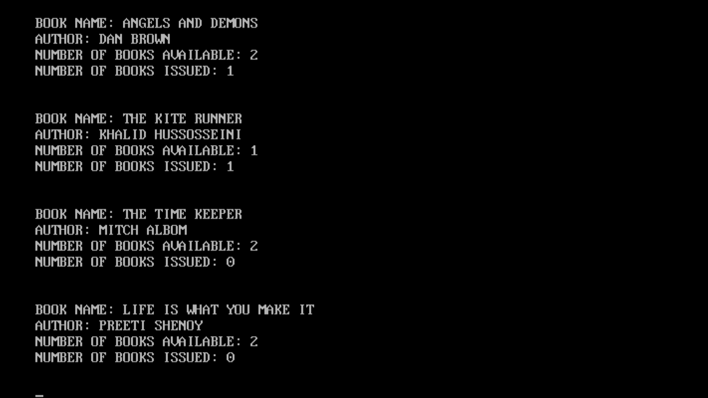

RETURNING BOOK

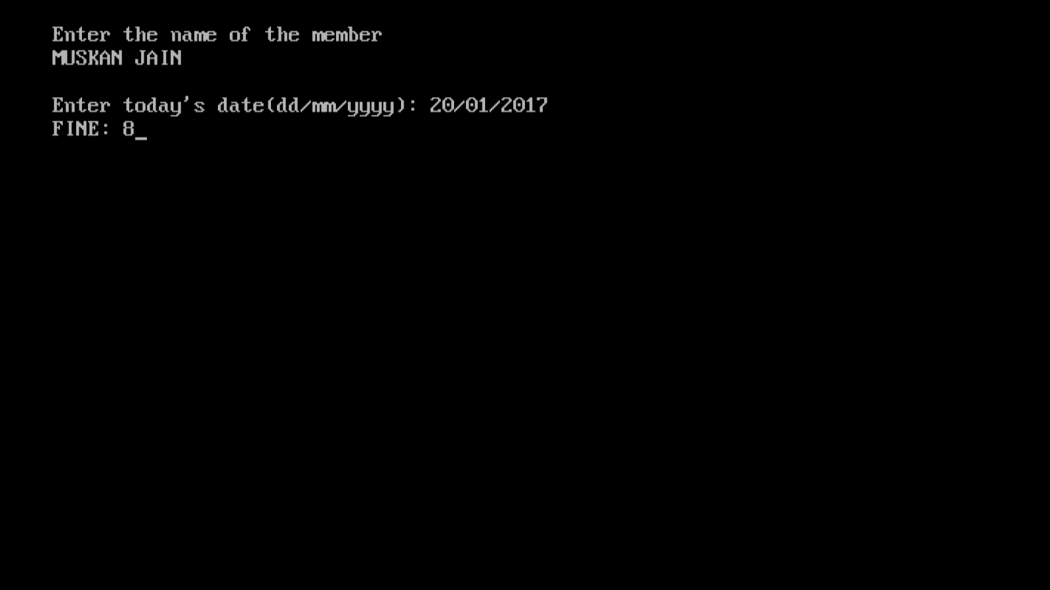

DELETING THE RECORDS OF A MEMBER

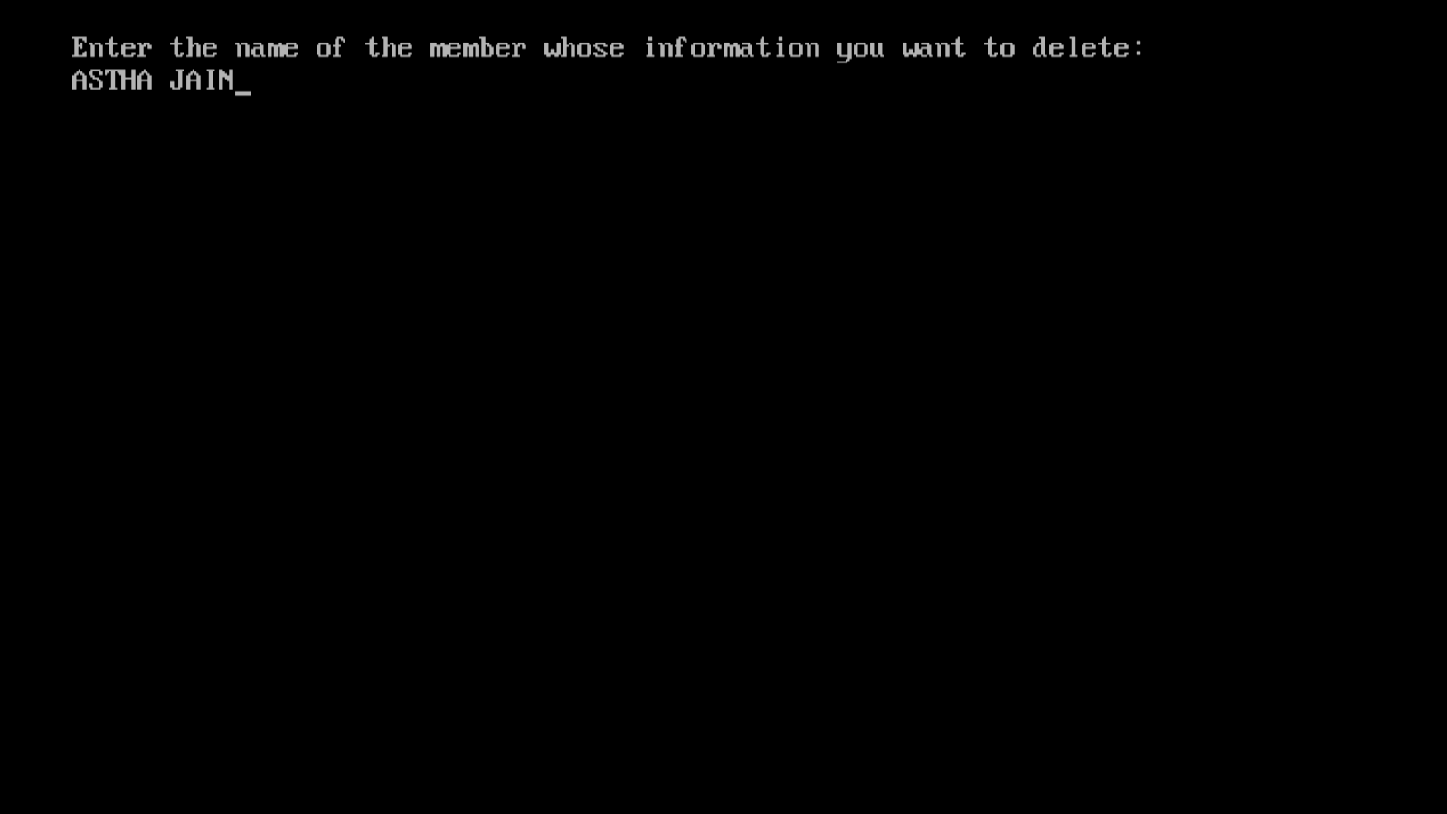

DISPLAYING DETAILS OF ALL MEMBERS

